**2.0 Principle of Good Report Design**

**2.1 Detail Report**  
Reservation Report on May 2019

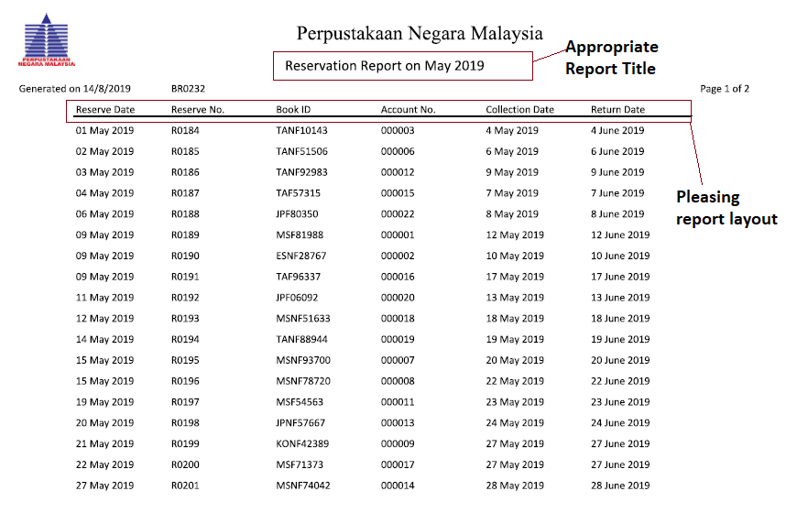

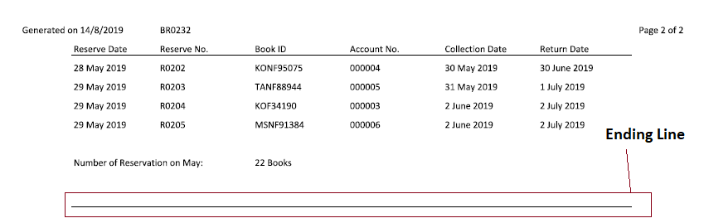

Appropriate report title (Name)  
A suitable name has to be provided to each report according to the nature of contents. It should also highlight upon its origin and the person for whom it is being prepared.

Pleasing report layout (Lable)  
All the data has been labelled clearly.

Meaningful report content  
Relevant accurate data is alone included in the report. If not so, it will involve unnecessary expenditure and the reports will be a waste.

Ending Line  
A report contains information which will tell the users when he or she has come the end of the document or a display screen.

**2.2 Exception Report**   
Report of Late Unpaid Fines over 7 Days for the Month Ended March, April and May 2019

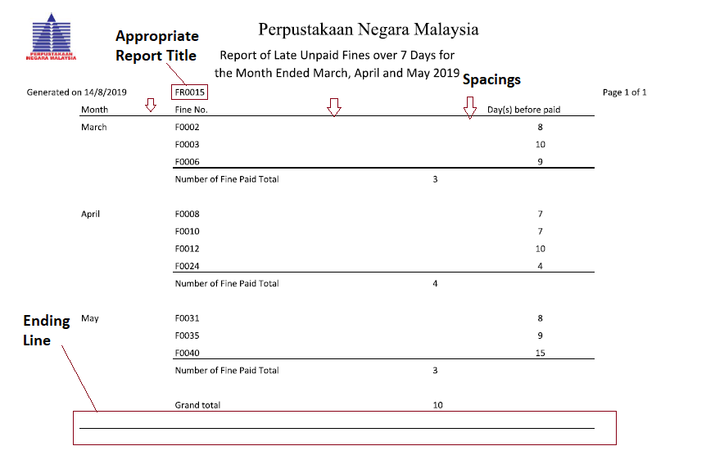

Appropriate report title (Revision)  
Where the same report has been produced more than one time, indicate the data of printing and version number.

Pleasing report layout (Spacing)  
The data in the table cannot be too concentrated need to have appropriate spacing and well layout on paper.

Meaningful report content (Accuracy)  
For example, the report of Late Unpaid Fines over 7 Days for the Month Ended March, April and May 2019 as far as possible, research report must be prepared carefully. It must be free from calculate mistakes.

Ending Line  
A report contains information which will tell the users when he or she has come the end of the document or a display screen.

**2.3 Summary Report**  
Number of books reserved by each language on Feb 2019

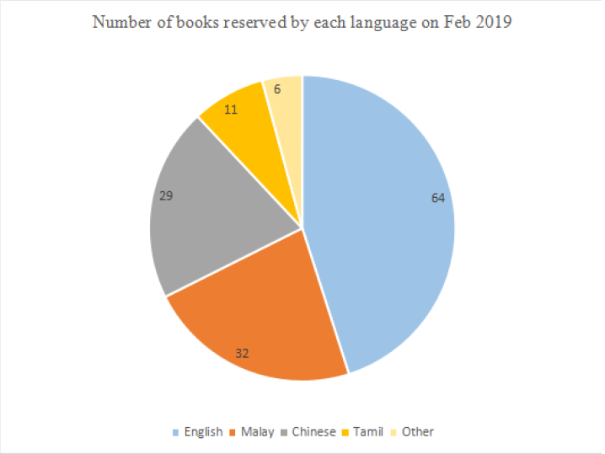

Appropriate report title   
The length of report title is streamline and meaningful. If the title of the report is too long it will become burdensome.

Pleasing report lay out  
Report must be attractive in all the important regards like size, colour, paper quality. Similarly, it should use liberally the charts, diagrams, figures, illustrations, pictures, and multiple colours.

Meaningful report content  
Information contained in this report is represented by showing pie chart that is useful for the manager making decision which language of books we need to buy. For example, the pie chart is showing the what language books have the highest reserve rate at that months.

Reliable  
Research report must be reliable. Manager can trust on it. He can be convinced to decide on the basis of research reports.